THS 500: DOGMATIC THEOLOGY

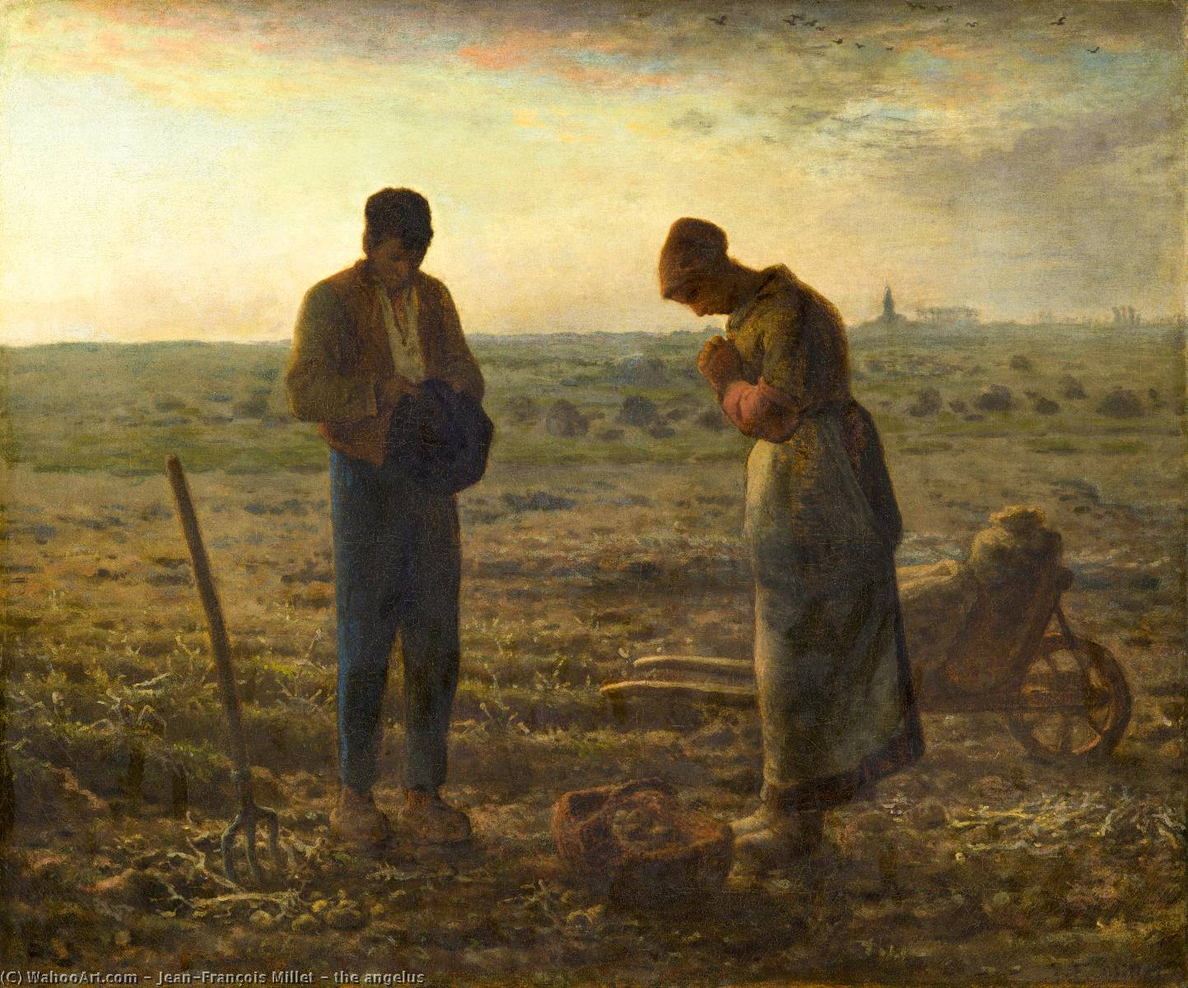

“To be a theologian is to pray, and to pray is to be a theologian.”
-Evagrius of Pontus (†399)

St. John’s Seminary
M.A. in Pastoral Ministry Program (MAPM)
Spring 2024
Three Credits
Prerequisite requirement: none
Course delivery: synchronously on Zoom and asynchronously on Canvas
Time: Mondays 7:00-9:00 PM PST
Zoom Meeting ID: 864 5709 4993
Passcode: 3Wtuha
Technical Requirements: Students will need a computer, internet connection, microphone, and camera
Faculty: Stuart Squires, Ph.D.
Contact: ssquires@stjohnsem.edu
Office Hours: Available by phone or Zoom by appointment

Course Description and Overview: This course explores the fundamental doctrines of the Catholic Church in a systematic fashion. Topics include Trinity, Christology, ecclesiology, Christian anthropology, and eschatology.

Program Learning Outcomes:
The MAPM has the following specific Program Learning Outcomes (PLOs), which rely on Bloom’s Taxonomy. These PLOs will be implemented and assessed throughout the curriculum. Graduates of the MAPM will be able to:
- Recall important historical events and theological concepts of the Catholic Intellectual Tradition.
- Explain the best practices of ministerial formation for children and adults.
- Implement theological and pastoral reflective praxis on the moral, spiritual, and social dimensions of the Church.
- Relate Catholic concepts in a practical way to parishioners, educators, catechists, and spiritual formators.
- Support the Church’s mission of outreach to those on the margins of society.
- Design and launch ministerial programs for parishes, schools, and campus ministries.

Course Level Student Learning Outcomes:
At the conclusion of this course, students will be able to: | Assessments (Direct and Indirect):
Recognize and master central doctrines such as Trinity, Christology, Soteriology, and Eschatology that have developed over the centuries (Aligns with PLO #1: see Curriculum Map). R. | Paper; Presentation
Implement best practices to translate Catholic doctrines to the pastoral level (Aligns with PLO # 3: see Curriculum Map). R. | Presentation; Paper Presentation
Connect these Catholic doctrines to the skills required to minister to those most in need (Aligns with PLO #4: See Curriculum Map). R,M. | Presentation; Paper presentation

Required Texts and Materials:
- Nichols, Aidan. The Shape of Catholic Theology. Collegeville: The Liturgical Press, 1991. ISBN: 0-8146-1909-6.
- Barron, Robert. Catholicism: A Journey to the Heart of the Faith. New York: Image, 2011. ISBN: 978-0-307-720-52-8.
- Favale, Abigail. The Genesis of Gender: A Christian Theory. San Francisco: Ignatius, 2022. ISBN: 978-62164-408-8.
- St. Paul VI. Humanae Vitae. [public domain copy found on Canvas].
- Butler, Sara. The Catholic Priesthood and Women: A Guide to the Teaching of the Church. Mundelein: Hillenbrand Books, 2007. ISBN: 978-59525-016-2.
- Barron, Robert. Letter to a Suffering Church: A Bishops Speaks on the Sexual Abuse Crisis. Parkridge: Word on Fire, 2019. ISBN: 978-1-943243-48-8.
- Other texts form the public domain can be found in PDF or WORD format on Canvas.

Grading System:

Grade |  | Meaning | Equivalent
 | A | Excellent | 100-92
 | A- |  | 91-90
 | B+ |  | 89-87
 | B | Good | 86-82
 | B- |  | 81-80
 | C+ |  | 79-77
 | C | Satisfactory | 76-72
 | C- |  | 71-70
 | D | Lowest Passing | 69-60
 | F | Failing | 59-0

Requirements and Format of the Class:
- Each week, students will watch a one-hour lecture that the professor has recorded before our Zoom meeting. This fulfills one of three hours of “regular and substantive” interaction.
- Each week, we will gather on Mondays on Zoom from 7:00-9:00 PST to discuss the readings for the week. This fulfills two of three hours of “regular and substantive” interaction.
- Students will have ten hours of reading a text or texts for the week. This fulfills the requirement for “out-of-class” work.

Evaluation and Grades: Grading rubrics for the following assignments can be found on Canvas
- Topic Presentation (100 points)
- Paper Presentation (100 points)
- Paper (100 points)

Topic Presentation:
- All students will give one 15-20 minute presentation during the Zoom class on a given topic.
- The topic could include a biography of an author, historical context of the text for the week, or history of the text, etc.

Paper Presentation:
- On the last day of class, students will present their papers to each other and to the professor

Paper:
- Students will write an 8–10-page paper that brings together the themes of the course with pastoral application:

  - Option 1: There many hotly contested issues in the Church today. Choose one of the issues and write a paper exploring how the Sense of the Faith should play a role in the continuing discussion of that issue. For example, most Catholics today in America have no problem with contraception. Although Church teachings are not decided by vote, how should the we take into account the statistical fact that most Catholics disagree with the Church on this issue?

  - Option 2: Bishop Barron’s Letter to a Suffering Church offers a theological interpretation of the sexual abuse scandal. Using it as a springboard, write a pastoral plan on how parishes or other communities can minister to the People of God, all of whom—one way or another—have been wounded by this crisis.

  - Option 3: Imagine you have been asked to present to the current confirmation class at your parish one of the doctrinal topics discussed in Bishop Barron’s book Catholicism. Create a presentation script and any visual aids that you would use for your presentation. How would you explain this topic to teenagers who may or may not be all that interested in what you have to say?
  - Option 4: you may do a standard research project that should consist of you making an argument. In other words, don’t just give a summary; have a thesis. Your topic must be approved by the teacher by Week 13. You must use 6-8 sources (only one encyclopedia; Wikipedia is never a valid source; only one dictionary; you may only have a maximum of two websites; you must have a minimum of 4 books or scholarly journal articles).

Academic Catalog: https://stjohnsem.edu/catalog

Student Handbook: https://stjohnsem.edu/documents/2022/10/Student%20Handbook%202022-23.pdf

Important Seminary Dates: https://stjohnsem.edu/events-news

Information for the learning management system:
- Canvas includes all of the relevant information for this semester, including links to videos, the syllabus, PDFs, etc.
- If you have any questions for problems with Canvas, please email me ASAP.

Library information:
  - Link: www. http://library.stjohnsem.edu/
  - Contact Information: (805) 482-2755
  - Library Hours:
    - Monday - Friday 8:00 am-4:30 pm
    - Closed daily: 12pm-1pm

Style: Students will use the Chicago Manual of Style and submit the paper via email as a Microsoft Word document.
Student Participation Responsibilities: Students are expected to come to class each week, complete all assignments on time, and participate fully. If students are unable to attend class in case of an emergency, please email me ASAP.

Netiquette: Students are expected to observe all standard practices of online respectful behavior.

Diversity Statement: SJS Student Handbook: “St. John's Seminary seeks to make its students aware of these cultures and give them the basic tools to serve effectively in any of the diocesan ministries…The Holy Spirit continues to bestow innumerable and diverse gifts on all the members of the Body of Christ for building up the kingdom of God and organizing the ministry of the Church. Seminarians [and MAPM students] must learn to work in collaboration with all whom the Spirit calls to service and leadership in the diverse ministries of the Church: women and men, the young and the old, the disadvantaged and the advantaged, the poor and the rich.”

The Attendance Policy: Punctual and regular attendance for the Zoom classes is the expected norm. Three unexcused absences are grounds for class failure. A student may occasionally be excused by the professor for serious reasons. An individual professor may require a student to compensate for absences that exceed the number of credits in a course. A student may make special arrangements for class attendance at the professor’s discretion or in accord with the methodology that the professor uses (see p. 68 of Academic Catalog).

The Students with Disabilities Policy: Reasonable accommodations are available for students with a documented disability. If you have a disability and may need accommodations to participate fully in this course, please speak with the professor by the end of the first week of the beginning of the semester.

The Academic Integrity Policy: Academic integrity is essential in maintaining the reputation of the individual student as well as that of the institution of St. John’s Seminary. Students and faculty are required to acknowledge the work of others in their writing and in their oral presentations. As future leaders of the Catholic community, our students are expected to exhibit moral integrity in all they do. There are academic and formational consequences for misrepresenting another’s work as one’s own (p. 67 of the Catalog).

The Plagiarism Policy: Plagiarism is the use of the ideas, words or other products of creative activity of another person, living or dead, without proper acknowledgment. It applies to words, music, visual arts, spoken words, scientific research - all products of intellectual activity. Academic integrity is essential in maintaining the reputation of the individual student as well as that of the institution of St. John’s Seminary. Students and faculty are required to acknowledge the work of others in their writing and in their oral presentations. Failure to do so is either an act of intentional dishonesty or the result of ignorance of the practices of scholarly research. As future leaders of the Catholic community, our students are expected to exhibit moral integrity in all they do. Plagiarism is not just a violation of academic protocol; it is a serious formation issue. We start with the assumption that education rather than punishment is the preferred response to an initial charge of academic dishonesty. In any case, the Seminary will keep a record of any such infringements in order to monitor repeated offenses.

Communication Policy: The professor will respond to communications from the students no later than one business day. The professor will only email the students’ St. John’s Seminary email account.

Assignment Submission Policy: Students will submit the paper assignment the professor in a Word document by the deadline.

Late-Work Policy: Students will lose 20% of the grade for every day that the assignment is late. Assignments will not be accepted after the sixth day that the assignment is due.

Copyright Policy: Users must abide by all local, state and federal laws that pertain to communication and publishing. This includes laws of libel, slander, harassment, and copyright law (p. 37 of the Student Handbook). Violating any software license agreement or copyright, including copying or redistributing copyrighted computer software, data, or reports without proper, recorded authorization (p. 38 of the Student Handbook).

Incomplete Course Work Policy: To be eligible for a grade of Incomplete, a student is required to obtain a Request for Incomplete form in the Academic Office and secure the professor’s written consent. The student must complete the coursework in the manner indicated by the professor within 30 days following the end of the semester. Under special circumstances, a student may apply for an additional 30-day extension. A Request for 30-Day Extension form must be submitted to the Academic Dean prior to the due date as shown on the original request form. If the deadline is not met, the student’s grade is permanently changed from I to F. No further extensions are given (p. 71 of the Academic Catalog).

Policy for Syllabus Changes: The professor reserves the right to make changes to this syllabus as necessary. If changes are made, the professor will communicate by email to the students.

SCHEDULE

UNIT I: FUNDAMENTAL THEOLOGY

Jan. 22: First Day of Class
- Nothing due on this first day of class

Jan. 29: The Role of Philosophy in Theology
- Nichols: Chapters one through seven

- Student Presentation: The different subfields of theology (expand on p. 24).

Feb. 5: Scripture as a Source of Theology
- Nichols: chapters eight through twelve

- Student Presentation: How was the Bible as we know it today put together?

Feb. 12: Tradition as a Source of Theology
- Nichols: chapters thirteen through sixteen

- Student Presentation: St. John Henry Newman

Feb. 19: NO CLASS: PRESIDENTS DAY

Feb. 26: Aids to Discernment in Theology
- Nichols: chapters seventeen through eighteen

- Student Presentation: Mystical Theology

UNIT II: CLASSIC TEACHINGS OF THE CHURCH

Mar. 4: Jesus and the Trinity
- Barron: Catholicism: Introduction through chapter three
- Creed of the Council of Nicaea (Canvas)
- Definition of Faith of the Council of Chalcedon (Canvas)
- Thomas Aquinas’ “Five Ways” (Canvas)

- Student Presentation: What does it mean to say that Jesus’ death was a “sacrifice?”

Mar. 11: Humanity, Mary, and the Church
- Barron: Catholicism: Chapter four through chapter six

- Student Presentation: The Catholic view of the Resurrection of Jesus and Us

Mar. 18: Sacraments, the Saints, Prayer, and the Last Things
- Barron: Catholicism: Chapter seven through Coda
- Gerard Manly Hopkins: “God’s Gradeur.” (Canvas)
- George Weigel: Chapter titled “The Old Cheshire Cheese, London—Chesterton’s Pub and a Sacramental World.” (Canvas).

- Student Presentation: Sacramental Imagination (“The World is Charged with the Grandeur of God”)

Mar. 25: NO CLASS: SPRING BREAK

Apr. 1: NO CLASS: EASTER MONDAY

UNIT III: CONTROVERSIES IN THE CHURCH

Apr. 8: The Human Person and Gender (I)
- Favale: Chapters One through Four
- Read Genesis 1-3 (any translation you want)

- Student Presentation: John Paul II’s understanding of the Feminine Genius: “Mulieris Dignitatem” (1988) and “Letter to Women” (1995).

Apr. 15: The Human Person and Gender (II)
- Favale: Chapters Five through Nine

- Student Presentation: FIND A NEW TOPIC BASED ON THIS SECOND WEEK OF FAVALE’S TEXT (FORMERLY THE VATICAN DOCUMENT ON EDUCATION AND TRANSGENDER

Apr. 22: Contraception
- Paul VI: Humanae Vitae

- Student Presentation: Before and After Humanae Vitae: the Pontifical Commission on Birth Control (before) and the response to Humane Vitae (after)

Apr. 29: The Male Priesthood
- Butler: All of The Catholic Priesthood and Women
- John Paul II: Ordinatio Sacerdotalis (Canvas)

- Student Presentation: The Catholic theology of priesthood

May 6: The Sexual Abuse Scandal
- Barron: All of Letter to a Suffering Church

- Student Presentation: The Catholic Church’s response to the sexual abuse crisis: the Dallas Charter and everything after.

May 13: Student Paper Presentations
- All students present their papers

May 20: NO CLASS
- PAPER DUE BY 5:00 PM PST BY EMAIL IN WORD DOCUMENT FORMAT.

