FC 6320: AMERICAN CATHOLICISM
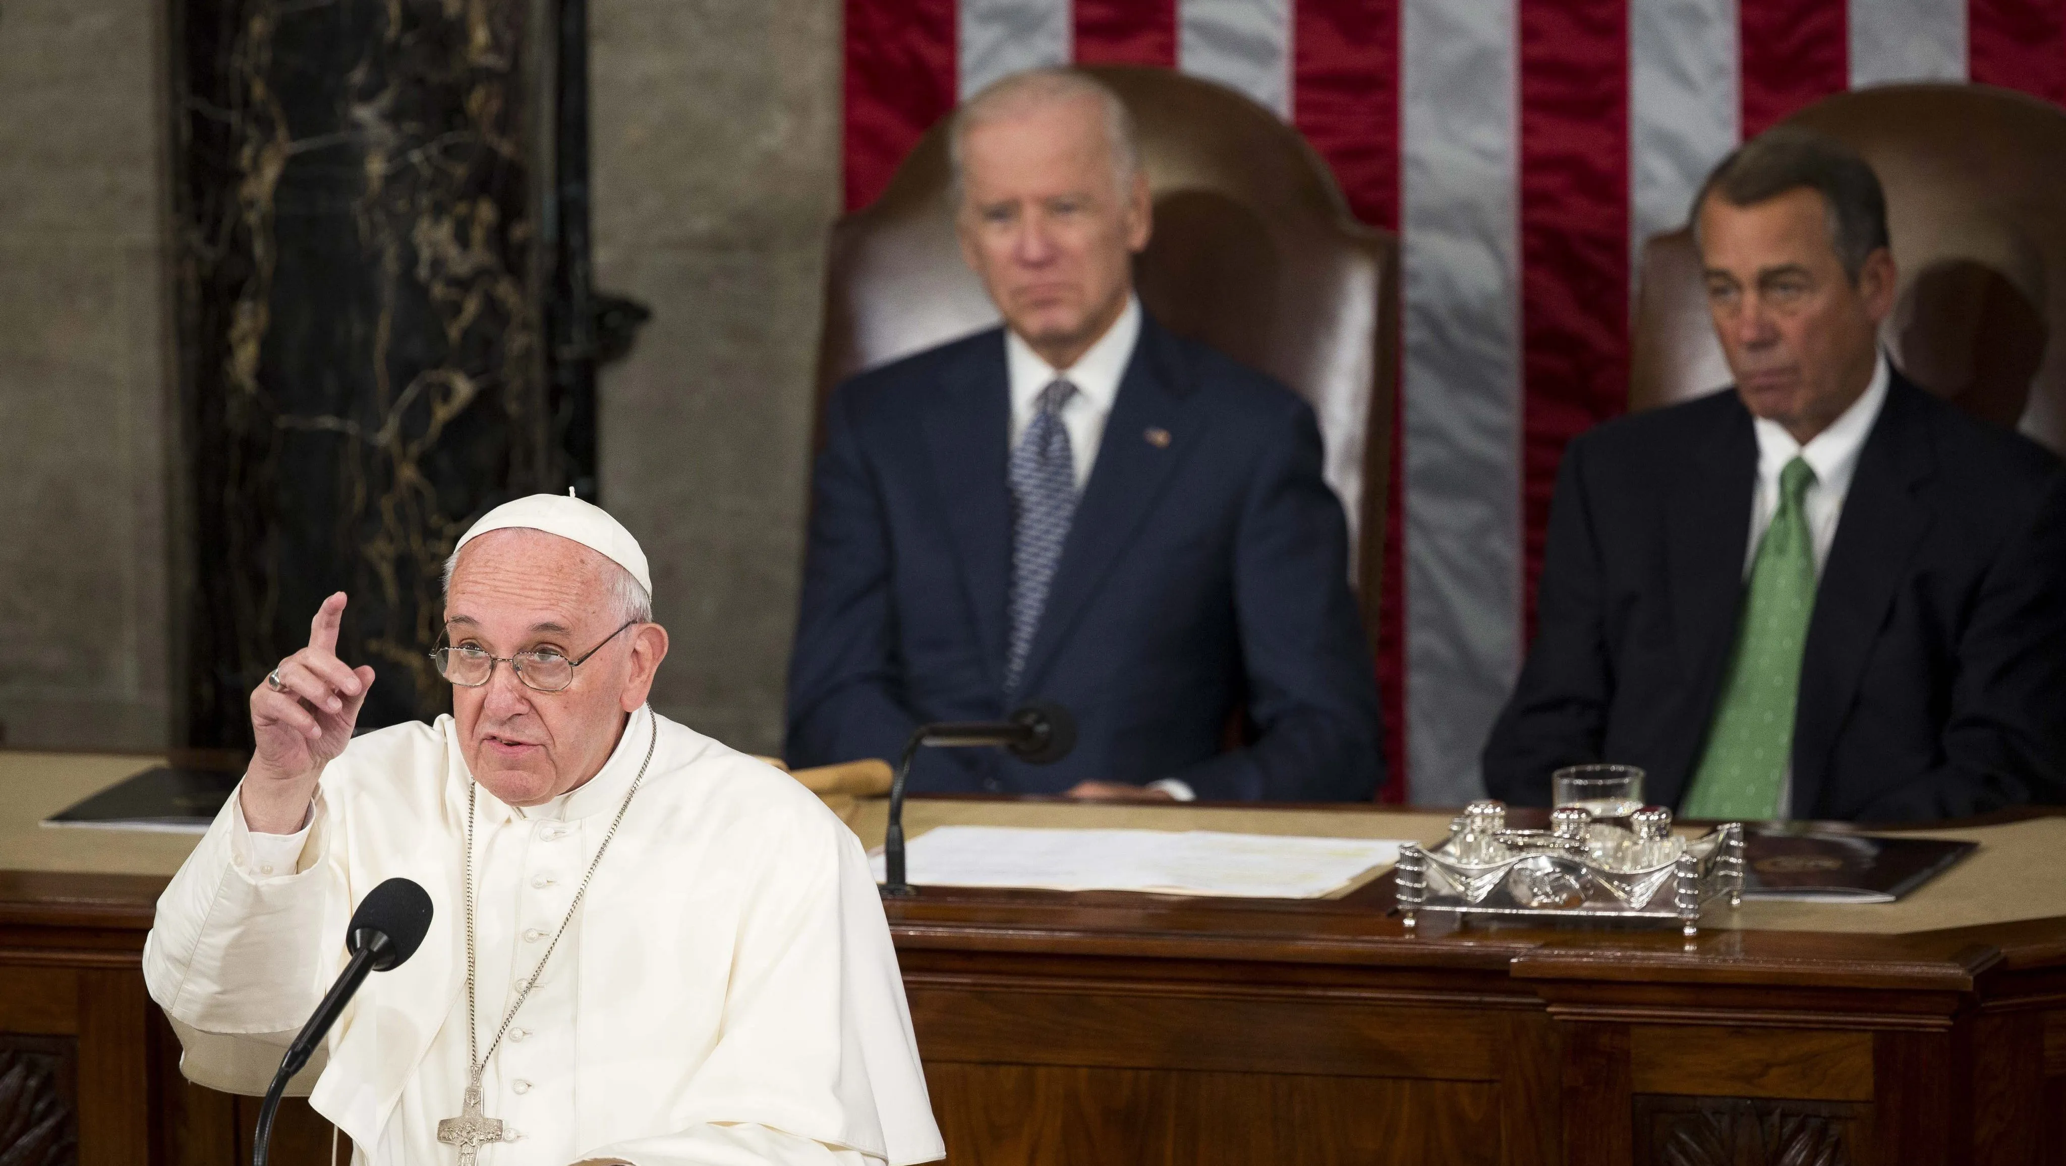
“The Catholics of the United States are at the same time the most submissive believers and the most independent citizens”
-Alexis de Tocqueville, Democracy in America (1840)

Stuart Squires, Ph.D.
Squires@stthom.edu
Office: Center for Faith and Culture House
Office Hours: Email me for times
Spring 2021:
Mon. 5:30-8:15

PURPOSE AND LEARNING OBJECTIVES:
This course provides an introduction to the history of Catholics in the United States, with a focus on how Catholics related to the larger dominant American culture. We will see that there were several different periods over the past 400 years: a period where Catholics suffered from virulent anti-Catholicism, a period of growing assimilation (or “Americanization”) to American culture, and a period of total assimilation to that culture. Students also will develop a variety of skills: the ability to perform sophisticated textual analysis, the art of public speaking, the ability to write cogently and precisely, the craft of persuasively making an argument, and the skill of speaking extemporaneously in an articulate fashion, to name only a few.
FORMAT OF THE CLASS:

- Classes will consist of lectures, close reading of primary texts, discussions, and (occasionally) videos.

BOOKS AND MATERIALS:
- Farrelly, Maura Jane. Anti-Catholicism in America, 1620-1860. Cambridge: Cambridge University Press, 2018. ISBN: 1316616363.
- Shaw, Russell. American Church: The Remarkable Rise, Meteoric Fall, and Uncertain Future of Catholicism in America. San Francisco: Ignatius Press, 2013. ISBN: 9781586177577.
- Carlin, David. The Decline and Fall of the Catholic Church in America. Manchester: Sophia Institute Press, 2003. ISBN: 1622821696.
- Grayston, Donald. Thomas Merton and the Noonday Demon: The Camaldoli Correspondence. Eugene: Cascade Books, 2015. ISBN: 1498209378.

REQUIREMENTS:
- Attendance: Students are expected to attend all classes.
- Lecture: Students will give a lecture during class on an author or text from the course.
- Paper Presentation: On the last day of class, students will give a presentation of a (very good) draft of their paper. Students will receive feedback from the teacher and the students, and then incorporate the comments into the final paper.
- A ten-page paper. There are several paper options:
  - Option 1: Students can do a research project of any individual or historical event related to our class. Make an argument, don’t just offer a summary.
  - Option 2: Since the beginning of this country (and continuing until today), many non-Catholics have claimed that Catholics can never truly be Americans, because of an assumed loyalty to Rome. Should Catholics even want to fully be Americans? If so, how can and should Catholics be both Catholic and American? How much of American culture should Catholics assimilate, and when should Catholics be the prophetic voice to our culture? Write an argumentative essay answering these questions.
  - Option 3: At the heart of the American political culture is the idea of self-governance, and at the heart of Catholicism is the idea of submission to the will of God as articulated through the teachings of the institutional Church. Can American Catholics believe in political representative government? Or, does a philosophy of representative government inevitably erode the Catholic Church’s foundation of divine revelation, hierarchy, and obedience? Write an argumentative essay answering these questions.
  - Option 4: In the Declaration of Independence, Thomas Jefferson penned one of the central American ideals: that “…all men are created equal, that they are endowed by their Creator with certain unalienable Rights, that among these are Life, Liberty and the pursuit of Happiness.” What did Jefferson mean by “Life, Liberty, and the pursuit of Happiness?” Is Jefferson’s understanding of “Life, Liberty, and the pursuit of Happiness” in harmony with a Catholic vision of the meaning of life, of true freedom, and of an authentic human flourishing? Where do the Jeffersonian vision and the Catholic vision overlap, and where do they not overlap? Write an argumentative essay answering these questions.
  - Option 5: In Part VII of his book The Decline and Fall of the Catholic Church in America, David Carlin offers multiple suggestions that the Catholic Church in America should follow in order to survive into the future. Write an argumentative paper that offers other suggestions that the Catholic Church in America must do not only to survive, but flourish.
  - Option 6: If a student has a particular skill set that relates to this class, the student may choose to do a project using that skill set.

Style: The student will use: Times New Roman; 12-point font; double spacing; 1 inch margins.
Paper Submission Policy: The paper will be submitted to the teacher via email.
Grade Distribution:
- Lecture:100 pts
- Paper: 100 pts
- Paper Presentation: 100

Grading Scale:
Grade |  | Meaning | Equivalent
 | A | Excellent | 100-92
 | A- |  | 91-90
 | B+ |  | 89-87
 | B | Good | 86-82
 | B- |  | 81-80
 | C+ |  | 79-77
 | C | Satisfactory | 76-72
 | C- |  | 71-70
 | D | Lowest Passing | 69-60
 | F | Failing | 59-0

POLICIES AND EXPECTATIONS:
- Students may submit assignments before the deadline. If any student is aware that he/she will miss a deadline of any type of assignment because of a scheduled event, that student MUST submit the work BEFORE the deadline, or else the student will not receive any credit for the assignment. If a student misses a deadline due to an unexpected event, the student may submit the work after the deadline with a 20% penalty. The sole exception to this policy is due to a case of extreme emergency.
- Students must do all of the reading for the week and bring all of the texts that are assigned for the week to class. Students may read texts off of a computer or tablet but may not do so with a telephone.
- There is to be no texting, emailing, or instant messaging during class.
- Students may not sleep in the class.
- Students must regularly check their email account as I will be emailing important information to it.
- Students with Disabilities Policy: If you have a disability and require accommodations, please contact Counseling and Disability Services at 713-525-2169 or 6953, or at cds@stthom.edu If you have a Letter of Accommodation from that office, I encourage you to discuss your accommodations and needs with me after class or during office hours at the beginning of the semester. I will work with you to ensure that accommodations are provided as appropriate.
- ACADEMIC INTEGRITY STATEMENT POLICY: There is to be absolutely no plagiarism in this class. If a student is caught, he or she will be reported to the University and will fail the assignment.
Plagiarism policy found on p. 45 of the Student Handbook:
- “Academic Integrity Every offense against academic honesty seriously undermines the teaching-learning process for which the University exists, and such offenses will be dealt with expeditiously according to the following criteria. A. Definition Academic dishonesty includes but is not limited to: 1. Cheating on an examination or test; for example, by copying from another’s work or using unauthorized materials before or during the test, including the use of electronic devices; 2. Plagiarism, which represents as one’s own the work of another, whether published or not, without acknowledging the precise source; 3. Participation in the academic dishonesty of another student, even though one’s own work is not directly affected; 4. Any conduct which would be recognized as dishonest in an academic setting.”

SCHEDULE FOR THE SEMESTER

PART I: Anti-Catholicism in America: 1620-1860, by Maura Jane Farrelly

Jan. 11: 1st day of Class

Jan. 18: NO CLASS (MLK DAY)

Jan. 25: Farrelly: pp. 1-103

Feb. 1: Farrelly: pp. 104-194

PART II: American Church: The Remarkable Rise, Meteoric Fall, and Uncertain Future of Catholicism in America, by Russell Shaw

Feb. 8: Shaw: pp. 1-118

Feb. 15: Shaw: pp. 119-215

PART III: The Decline and Fall of the Catholic Church in America, by David Carlin

Feb. 22: Carlin: pp. 3-110

Mar. 1: Carlin: pp. 113-208

Mar. 8: NO CLASS (SPRING BREAK)

Mar. 15: Carlin: pp. 211-315

Mar. 22: Carlin: pp. 319-385

PART IV: Thomas Merton and the Noonday Demon: The Camaldoli Correspondence, by Donald Grayston

Mar. 29: Grayston: pp. 1-54

Apr. 5: NO CLASS (EASTER)

Apr. 12: Grayston: pp. 55-160

Apr. 19: Grayston: pp. 204-235; 255-279

END OF CLASS

Apr. 26: PAPER PRESENTATIONS

May 3: PAPER DUE BY 5:00 PM CST

PRESENTATION TOPICS

- Jan. 25: Charles Carroll of Carrollton_______________________________________________

- Feb. 1: Orestes Brownson________________________________________________________

- Feb. 8: Isaac Hecker_____________________________________________________________

- Feb. 15: John Courtney Murray, S.J.________________________________________________

- Feb. 22: JFK’s Catholic identity in 1960 election______________________________________

- Mar. 1: John Dewey_____________________________________________________________

- Mar. 15: John Stewart Mill________________________________________________________

- Mar. 22: Secularism_____________________________________________________________

- Mar. 29: The conversion story of T. Merton __________________________________________

- Apr. 12: The histories and differences of eremitic and cenobitic forms of monasticism_________

- Apr. 19: Merton and his nurse, Margie_______________________________________________

