Th. 105: INTRODUCTION TO THE NEW TESTAMENT
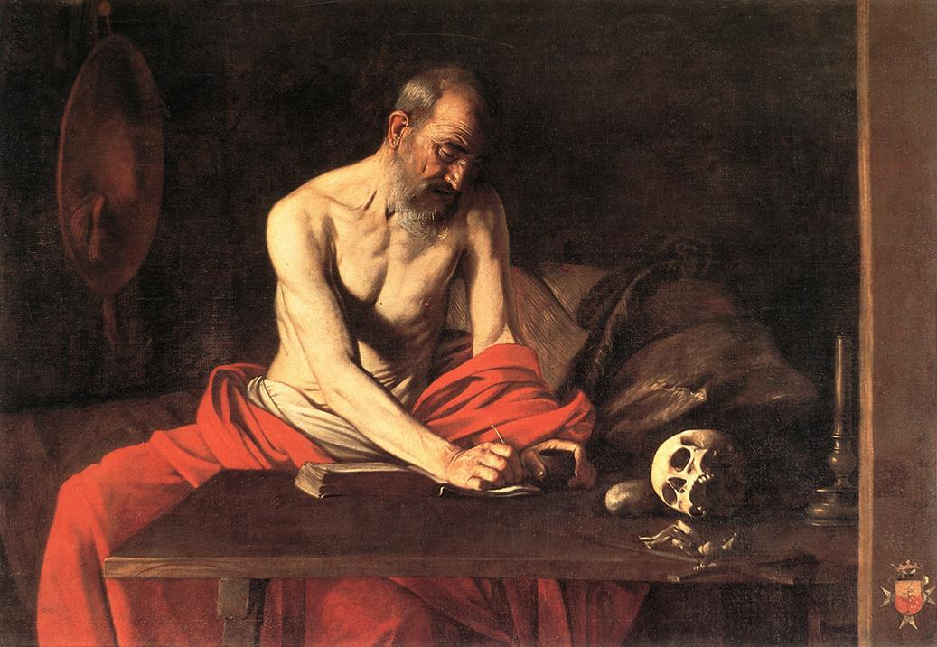
“To be ignorant of Scripture is to be Ignorant of Christ”
-- St. Jerome († 420 A.D.)

Stuart Squires, Ph.D.
Stuart.Squires@brescia.edu
Office Hours: Mon.-Wed. 11-12, 1-2; Thurs. 11-12, 1-2, 3-4; Fri. 11-12
(Appointments highly recommended)
Office: Admin. #137
Fall 2016
MWF 9:00-9:50 / (S226)

PURPOSE AND LEARNING OBJECTIVES:
This course will survey the majority of the New Testament texts. Important dates, locations, people, and terms (e.g., Pharisees and Sadducees) will be discussed. Special attention will be paid to the different titles of Jesus (e.g., Son of God, Son of Man, Christ) to determine how each of these texts answered the question: “who is Jesus?” We will compare and contrast how, in similar and different ways, each of these texts paints the picture of Jesus and the Church in the first century. We also will read Dei Verbum from Vatican II and selections from Verbum Domini by Pope Benedict XVI to see how the Catholic Church understands the function of Scripture and how She interprets Scripture. By the end of the semester, students will have a strong foundation in the “who, what, when, where, why, and how” of the New Testament.
FORMAT OF THE CLASS:

- The class will begin with a review of the previous lesson: the best way to learn something is by repetition.
- Classes will consist of lectures, close reading of primary texts, discussions, and (occasionally) videos.

TEXTBOOKS AND MATERIALS:

- Anselm Academic Study Bible. New American Bible Revised Edition. Winona: Anselm Academic, 2013. ISBN 978-1-59982-124-5. Students MUST use this particular edition as we will be using the introductory essays, footnotes, and maps.
- A variety of other primary source material will also be used. This material will be found on the class LibGuide. The password is: theology

REQUIREMENTS:

- Attendance: Students are expected to attend all classes. A student missing twenty percent or more of the scheduled class meetings for a course will be denied credit. A student is counted present only when the student signs the attendance sheet at the beginning of the class.

- Friday Forms (FF): Most Fridays, students will submit a completed form that shows the text of the week has been closely read and digested. The form may be found on the class LibGuide. Students must offer specific examples from the text to support their claims, and give chapter and verse references with the examples. Please staple your forms if there more than one page. This assignment is pass / fail.

- Reflection Assignment: Students will write a 2-3 page reflection on Pope Benedict XVI’s Verbum Domini.

- Library Exercise: On the day that we visit the library, students will have a biblical exegesis assignment to complete in small groups.

- Midterm exam and final exam: Make sure your travel plans at the end of the semester do not conflict with the exam time and date. Students who need to take an exam at a time other than when the exam is scheduled will be charged $5.00 (midterm) or 10.00 (final) by the teacher (see Faculty Handbook 3.4.6).

- Paper: Students will write a 5-7 page paper. There are several options from which to choose. Students will submit their papers two ways. First, they will submit a hardcopy on the day that the paper is due. Second, students will upload a copy to Turnitin. Failure to do both will result in a 0.

  - Option 1: You may do a standard research project that should consist of you making an argument. In other words, don’t just give a summary; have a thesis. Your topic must be approved by the teacher by Week 13. You must use 6-8 sources (only one encyclopedia; Wikipedia is never a valid source; only one dictionary; you may only have a maximum of two websites; you must have a minimum of 4 books or scholarly journal articles).

  - Option 2: The reserve section in the library (Religion 200s) is filled with excellent biblical commentaries (to name just a few: The Ancient Christian Commentary on Scripture, Anchor Bible, Jerome Biblical Commentary, Catholic Commentary on Holy Scripture, Eerdman’s Commentary on the Bible, Harper Collins Bible Commentary, The Interpreter’s Bible, International Critical Commentary, New Bible Commentary, Oxford Bible Commentary, Women’s Bible Commentary, New Interpreter’s Bible Commentary, and Sacra Pagina). Choose a passage from the New Testament (one to three chapters) and then investigate from three of these commentaries different ways this passage has been interpreted. Which of these interpretations use the exegetical principles found in Verbum Domini and which do not? Which of these interpretations seem most appealing to you? Why?

  - Option 3: Compare and contrast the information on Paul’s biography from Acts with the personal information he tells us about himself in his letters. How are the presentations of him similar? How are they different?

  - Option 4: Who killed Jesus? Why did they kill him? The answers to these two questions are trickier than you might expect. Read through the four gospels and compare and contrast how each one of them answer these questions. Are the answers clear, or foggy?

  - Option 5: Students may do a project—paper or other— that is not listed here and employs the particular skill sets of the student. If this option is chosen, students must get the project approved by the instructor by week 13.

Style: The student will use: Times New Roman; 12 point font; double spacing; 1 inch margins.

Grade Distribution:
Friday Forms: 100 pts
Reflection Assignment: 10 pts
Library Assignment: 10 pts
Midterm: 100 pts
Final: 100 pts
Paper: 100 pts

Grading Scale:
Grade |  | Meaning | Equivalent
 | A | Excellent | 100-92
 | A- |  | 91-90
 | B+ |  | 89-87
 | B | Good | 86-82
 | B- |  | 81-80
 | C+ |  | 79-77
 | C | Satisfactory | 76-72
 | C- |  | 71-70
 | D | Lowest Passing | 69-60
 | F | Failing | 59-0

POLICIES AND EXPECTATIONS:

- If the student chooses to come to class, he or she must not be tardy, as arriving late is distracting to the instructor, disruptive to colleagues, and it is disrespectful. If the student is late, the student should sit in the row closest to the door (which should remain empty) so as to cause as little disturbance as possible.

- Students may submit assignments before the deadline. If any student is aware that he/she will miss a deadline of any type of assignment because of a scheduled event, that student MUST submit the work BEFORE the deadline, or else the student will not receive any credit for the assignment. If a student misses a deadline due to an unexpected event, the student may submit the work after the deadline with a 20% penalty. The sole exception to this policy is if the teacher hears from the Dean of Students due to a case of extreme emergency.

- Students must do all of the reading for the week and bring all of the texts that are assigned for the week to class.

- There is to be no texting, emailing, or instant messaging during class.

- Students may not sleep in the class.

- Students must regularly check their Brescia email account as I will be emailing important information to it.

- STUDENTS WITH DISABILITIES POLICY: Reasonable accommodations are available for students with a documented disability. If you have a documented disability and need accommodations to participate fully in this course, please contact Mr. Dwight Ottman (Office 411 on the fourth floor of the Science Building). All academic accommodations must be approved in advance through his office. Please drop by or call 270-686-4281 to make an appointment, or contact him by email at dwight.ottman@brescia.edu.

- ACADEMIC INTEGRITY STATEMENT POLICY: There is to be absolutely no plagiarism in this class. If a student is caught, he or she will be reported to the University and will fail the assignment. If the grade on that assignment drops the student’s overall grade to a “F” for the semester, the student will fail the course.

Plagiarism policy found on p. 44 of the Brescia Catalog:
An instructor who becomes aware of an act of deliberate academic dishonesty, including plagiarism, should report the student(s) involved to the Academic Dean and describe the disciplinary action proposed. (Note: Plagiarism is defined as the deliberate use of another‘s ideas, work, or words as one‘s own, without properly documenting and crediting the original source.) Purchasing or copying another‘s work and using it as one‘s own, cheating on tests, refusing to do one‘s share of group work for which all will receive the same grade, and not doing one‘s own homework are other examples of academic dishonesty.

- This class fulfills the major requirement for the Theology major and is a GER approved course.

BRESCIA UNIVERSITY EDUCATIONAL OUTCOMES (BUEOs)

- Brescia University graduates will demonstrate the ability to think critically, analyze information, and communicate effectively. a. Critical Thinking b. Information Analysis c. Effective Communication

- Thinking: Through the close reading of primary texts and writing term paper, students will demonstrate the skill of applying logic, reason from hypothesis to conclusion, identify core issues, and evaluate judgments of the arguments of the authors read in class.
- Information Analysis: Through the term paper required by all students, they will demonstrate their skill of observing, investigating and analyzing information from disparate sources.
- Communication: Through the quizzes, midterm, final, and term paper, students will demonstrate their skill of articulating their understanding and discernment of what they have read.

- Brescia University graduates will attain competence in and apply a field of study in readiness for graduate school or a career in an appropriate field. a. General Education Courses MAY address this Outcome b. Primarily addressed through courses for the MAJOR

- Through this class, students will learn about biblical literacy. This is important for graduate school because, regardless of the specific field that the student would study in graduate school, a strong background on the Bible is necessary.

- Brescia University graduates will possess the capacity to adapt to diverse environments. a. General Education Courses MAY address this Outcome b. Primarily addressed through courses for CO-CURRICULAR programs

- Often times, studying the Bible in a university setting is challenging to students because if they come from a Christian background they studied the Bible in a different way. Studying the Bible in a university setting will force students to adapt to a new vision of the Bible.

- Brescia University graduates will understand and apply ethical standards in promoting justice and service to others. a. Ethical Standards (understand and apply) b. Justice c. Service

- By reading the New Testament, students will encounter many of Jesus’ ethical teachings, such as the Beatitudes

BRESCIA GENERAL EDUCATION STUDENT LEARNING OUTCOMES

- Students will read perceptively, write clearly and analytically, and speak effectively. a. Perceptive Reading b. Analytical Writing c. Effective Speaking

- Students will learn how to read closely by practice. Students will read primary and secondary literature that will help students develop the skill of perceptive reading. The writing assignments that students have will develop the skills of analytic writing. Students will develop the skill of effective speaking by interaction with their colleagues.

- Students will think critically

- By interacting and engaging with the primary source material, students will think critically about the Catholic biblical tradition.

- Students will synthesize and process information using traditional and technological tools. a. Research and Research Papers/Projects b. Technology Use

- Students will have a field trip to the library. At the library, students will be asked to do research on how two different individuals interpreted the same biblical passage.

- Students will develop their knowledge of theology and philosophy, harmonizing that knowledge with other disciplines

- Through reading the Bible, students will begin to get a taste of the Catholic theological tradition. For example, by reading St. Paul, students will learn about predestination.

THEOLOGY MAJOR EDUCATIONAL OUTCOMES
Students in biblical studies classes in offered in the theology area will demonstrate basic biblical literacy, and an understanding of the historical situation of the biblical periods. Students, for example, will learn about important concepts, places, and people, such as the Pharisees and the Sadducees.

- This entire course is interested in biblical literacy. Although some biblical scholarship is also included, the main focus of the class to get students to understand the basic who, what, when, where, why, and how of the Bible. Students are tested on definitions of terms and titles of Jesus as well as knowledge of maps.

Signature Assignment: Essay

The Schedule for the Semester

The Church’s Understanding of the Nature of Revelation
Fri. Aug. 19: Vatican II: Dei Verbum (handout)

Gospel According to Mark:
Mon. Aug. 22: Chapters 1 through 6
Wed. Aug. 24: Chapters 7 through 11
Fri. Aug. 26. (FF DUE); Chapters 12 through 16

The Gospel According to Matthew:
Mon. Aug. 29: Chapters 1 through 9
Wed. Aug. 31: Chapters 10 through 18
Fri. Sep. 2: (FF DUE); Chapters 19 through 28

The Gospel According to Luke:
Mon. Sep. 5: NO CLASS
Wed. Sep.7: Chapters 1 though 12
Fri. Sep. 9: (FF DUE) Chapters 13 through 24

The Gospel According to John:
Mon. Sep. 12: Chapters 1 through 7
Wed. Sep. 14: Chapters 8 through 14
Fri. Sep. 16: (FF DUE); Chapter 15 through 21

Acts of the Apostles:
Mon. Sep. 19: Chapters 1 through 10
Wed. Sep. 21: Chapters 11 through 20
Fri. Sep. 23: (FF DUE); Chapters 21 through 28

The Church’s Understanding of the Interpretation of Scripture:
Mon. Sep. 26: Verbum Domini by Pope Benedict XVI, pp. 1-9 (found on LibGuide)
Wed. Sep. 28: Verbum Domini by Pope Benedict XVI, pp. 10-19 (found on LibGuide)
Fri. Sep. 30: (Reflection Assignment DUE); Verbum Domini by Pope Benedict XVI, pp. 19- 27 (found on LibGuide)

Midterm
Mon. Oct. 3: REVIEW FOR MIDTERM
Wed. Oct. 5: MIDTERM
Fri. Oct. 7: NO CLASS

Paul’s First Letter to the Thessalonians and Galatians:
Mon. Oct. 10: NO CLASS
Wed. Oct. 12: (Acts 17:1-15); All of 1 Thessalonians
Fri. Oct. 14: All of Galatians

Paul’s Letters to the Philippians, Colossians, and Ephesians:
Mon. Oct. 17: (Acts 16); All of Philippians
Wed. Oct. 19: All of Colossians
Fri. Oct. 21: (FF DUE); All of Ephesians

Paul’s First Letter to the Corinthians:
Mon. Oct. 24: (Acts 18: 1-17); 1 Corinthians 1 through 6
Wed. Oct. 26: Chapters 7 through 11
Fri. Oct. 28: (FF DUE); Chapters 12 through 16

Paul’s Second Letter to the Corinthians:
Mon. Oct. 31: (Exodus 34:27-35); 2 Corinthians 1 through 4
Wed. Nov. 2: Chapters 5 through 8
Fri. Nov. 4: (FF DUE); Chapters 9 through 13

Paul’s Letter to the Romans:
Mon. Nov. 7: Romans 1 through 6
Wed. Nov. 9: (Genesis 3); Chapters 7 through 11
Fri. Nov. 11: (FF DUE); Chapters 12 though 16

Different Biblical Interpretations of Specific Passages:
Mon. Nov. 14: Jesus and the Canaanite Woman (LibGuide)
Wed. Nov. 16: Parable of the Lost Sheep (LibGuide)
Fri. Nov. 18: Jesus Curses the Figtree (LibGuide)

Thanksgiving Week
Mon. Nov. 21: Field Trip to the Library (Library Exercise DUE)
Wed. Nov. 23: NO CLASS
Fri. Nov. 25: NO CLASS

Letter of James:
Mon. Nov. 28: (Galatians 3; Romans 4; Hebrews 11); James 1 through 5
Wed. Nov. 30: (FF DUE); Discussion (nothing to read. Friday Form due today instead of May 1)
Fri. Dec. 1: (PAPER DUE); FINAL REVIEW

FINAL EXAM: Wednesday, December 7th @ 8:05-10:00

Th. 105: The New Testament Statement of Compliance

I, ___________________________________, have read the entire syllabus for Th. 105 “The New Testament.” If there were any parts of the syllabus I did not originally understand, I have asked the professor for clarification.
By signing this paper and remaining enrolled in this class, I acknowledge that I have understood the syllabus—including (but not limited to) the policies and expectations, especially concerning attendance, tardiness, reading expectations, preparedness, and plagiarism. Not only do I understand the requirements of the class, but I will abide by them.

Signature:________________________________
Date:____________________________________

Th. 105: The New Testament Statement of Compliance

I, ___________________________________, have read the entire syllabus for Th. 105 “The New Testament.” If there were any parts of the syllabus I did not originally understand, I have asked the professor for clarification.
By signing this paper and remaining enrolled in this class, I acknowledge that I have understood the syllabus—including (but not limited to) the policies and expectations, especially concerning attendance, tardiness, reading expectations, preparedness, and plagiarism. Not only do I understand the requirements of the class, but I will abide by them.

Signature:________________________________
Date:____________________________________

