FC 6359: Catholic Teachings on Education
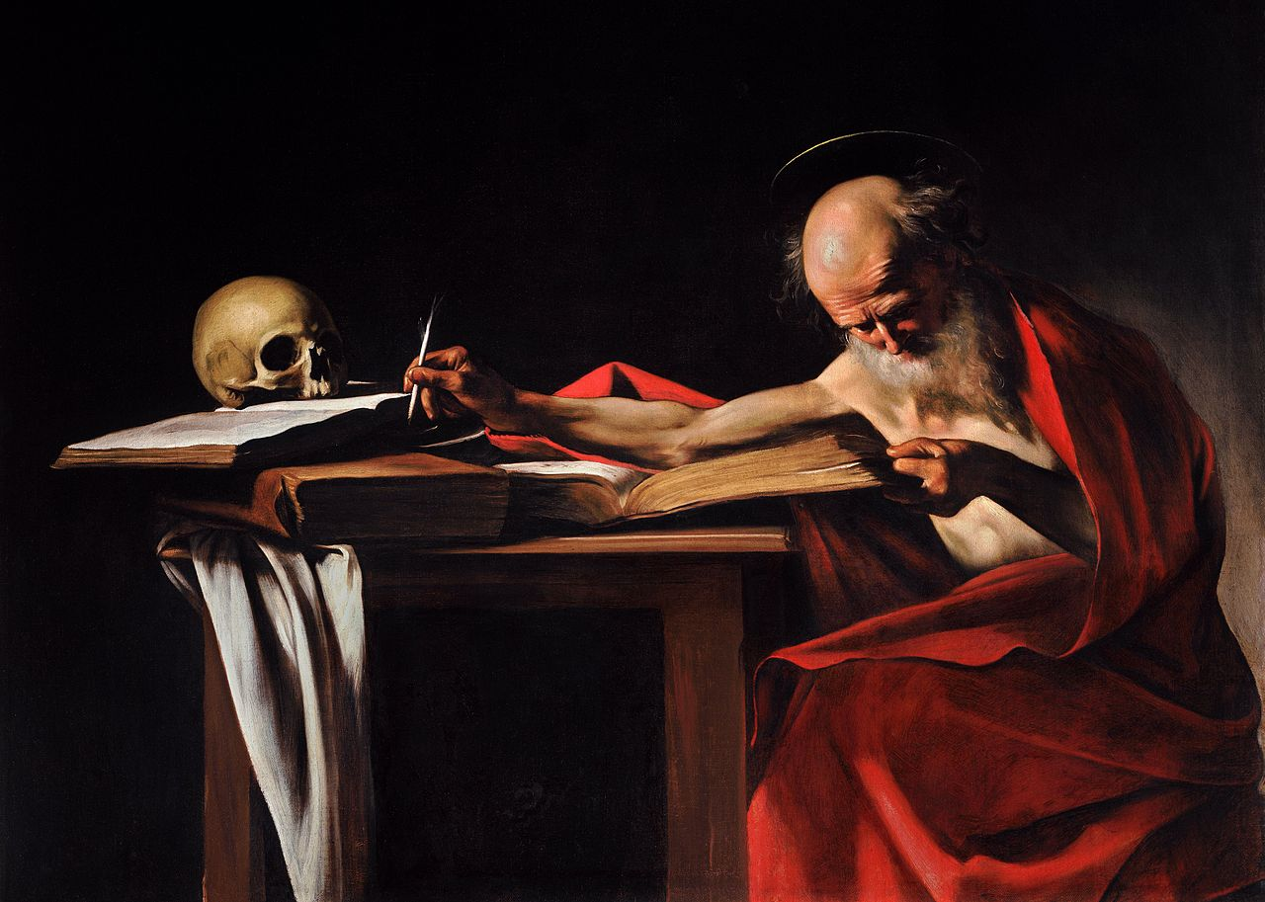
“For a true education aims at the formation of the human person in the pursuit of his ultimate end and of the good of the societies of which, as man, he is a member, and in whose obligations, as an adult, he will share.”
-Vatican II (Gravissimum educationis)

Stuart Squires, Ph.D.
Squires@stthom.edu
Office: Center for Faith and Culture House
Office Hours: Email me for times
(Appointments highly recommended)
Spring 2020: Wed. 5:30-8:15 (Malloy 025)

PURPOSE AND LEARNING OBJECTIVES:
This course investigates the rich tradition of the Church’s teaching on education, while challenging students to bring this tradition to bear on related contemporary issues. It explores the many different ways that Catholic education—with its emphasis on beauty, enculturation, formation, and liturgy—stands apart from the dominant culture’s assumptions that education is ultimately ordered towards employment and financial success. By the end of the semester, students will be able to articulate the central points of Catholicism’s philosophy of education. Students also will develop a variety of skills: the ability to perform sophisticated textual analysis, critical and analytical thinking, the art of public speaking, the ability to write cogently and precisely, the craft of persuasively making an argument, and the skill of speaking extemporaneously in an articulate fashion, to name only a few.
FORMAT OF THE CLASS:

- Classes will consist of lectures, close reading of primary texts, discussions, and (occasionally) videos.

BOOKS AND MATERIALS:

- Augustine. Against the Academicians and the Teacher. New York: Hackett, 1995. (ISBN: 0872202127).
- Clayton, David. The Way of Beauty: Liturgy, Education, and Inspiration for Family, School, and College. Chicago: Angelico Press, 2015. (ISBN: 1621381412).
- Dawson, Christopher. The Crisis of Western Education. Washington, DC: The Catholic University of America Press, 2010. (9780813216836)
- Topping, Ryan. The Case for Catholic Education: Why Parents, Teachers, and Politicians Should Reclaim the Principles of Catholic Pedagogy. Chicago: Angelico Press, 2015. (ISBN: 1621381455).
- A variety of other primary source material will also be used. This material will be found on Blackboard.

REQUIREMENTS:
- Attendance: Students are expected to attend all classes.
- Lecture: Students will give a lecture during class on an author or text from the course.
- Paper Presentation: On the last day of class, students will give a presentation of a (very good) draft of their paper. Students will receive feedback from the teacher and the students, and then incorporate the comments into the final paper.
- A ten-page paper. There are several paper options:
  - Option 1: Choose a topic discussed this semester, or one that is related to the themes of our semester, and do a standard research project. Make an argument, don’t just offer a summary.
  - Option 2: In the “Afterword” of his book The Way of Beauty, David Clayton briefly describes what he thinks an art school that is intent on forming artists in true beauty should look like. This hypothetical school looks very different than art schools as they currently exist in our society. In a similar way, consider the different perspectives we have seen this semester, and design a hypothetical Catholic school—primary, secondary, undergraduate, or graduate. What would it be like? What would be the telos of this school? How would it be different from the ways current Catholic, or even public, schools look today? How would it be organized? What would its architectural and artistic atmosphere be like? What would the curriculum be? How would they be taught? What extra-curricular activities be offered, or not offered? What role for play would there be? What would the schedule look like? What expectations would you have of the teachers? What would the course of the day look like? What would be the role of liturgy? Would there be a dress code? What role would the parents play?
  - Option 3: Compare and contrast the Land O’ Lakes Statement and Pope John Paul II’s Ex corde ecclesiae. How are these two visions of higher education similar, and how are they different? Are the differences contradictory? Offer an assessment of them both. What are their strengths, and what are their weaknesses? Do you find one more compelling than the other? Make an argument, don’t just give an opinion.
  - Option 4: Tertullian’s “Against Heretics,” and Basil of Caesarea’s “Address to Young Men on the Reading of Greek Literature” offer different visions about how Christians should (or should not) embrace non-Christian culture. Michael O’Brien’s A Landscape with Dragons offers a contemporary application of this question in his exploration of Disney movies. Assess O’Brien’s argument. With whom does he seem to agree? What do you think of his argument? Does he have sound arguments, or are his fears misplaced? Make an argument, don’t just give an opinion.
  - Option 5: If a student has a particular skill set that relates to this class, the student may choose to do a project using that skill set.

Style: The student will use: Times New Roman; 12 point font; double spacing; 1 inch margins.
Paper Submission Policy: The paper will be submitted to the teacher via email.
Grade Distribution:
- Lecture:100 pts
- Paper: 100 pts
- Paper Presentation: 100

Grading Scale:
Grade |  | Meaning | Equivalent
 | A | Excellent | 100-92
 | A- |  | 91-90
 | B+ |  | 89-87
 | B | Good | 86-82
 | B- |  | 81-80
 | C+ |  | 79-77
 | C | Satisfactory | 76-72
 | C- |  | 71-70
 | D | Lowest Passing | 69-60
 | F | Failing | 59-0

POLICIES AND EXPECTATIONS:
- Students may submit assignments before the deadline. If any student is aware that he/she will miss a deadline of any type of assignment because of a scheduled event, that student MUST submit the work BEFORE the deadline, or else the student will not receive any credit for the assignment. If a student misses a deadline due to an unexpected event, the student may submit the work after the deadline with a 20% penalty. The sole exception to this policy is due to a case of extreme emergency.
- Students must do all of the reading for the week and bring all of the texts that are assigned for the week to class. Students may read texts off of a computer or tablet but may not do so with a telephone.
- There is to be no texting, emailing, or instant messaging during class.
- Students may not sleep in the class.
- Students must regularly check their email account as I will be emailing important information to it.
- Students with Disabilities Policy: Accommodations can be made for physical and learning disabilities. This must be discussed with the professor by the end of the second week.
- ACADEMIC INTEGRITY STATEMENT POLICY: There is to be absolutely no plagiarism in this class. If a student is caught, he or she will be reported to the University and will fail the assignment.
Plagiarism policy found on p. 45 of the Student Handbook (Please be familiar with the entire Student Handbook):
- “Academic Integrity Every offense against academic honesty seriously undermines the teaching-learning process for which the University exists, and such offenses will be dealt with expeditiously according to the following criteria. A. Definition Academic dishonesty includes but is not limited to: 1. Cheating on an examination or test; for example, by copying from another’s work or using unauthorized materials before or during the test, including the use of electronic devices; 2. Plagiarism, which represents as one’s own the work of another, whether published or not, without acknowledging the precise source; 3. Participation in the academic dishonesty of another student, even though one’s own work is not directly affected; 4. Any conduct which would be recognized as dishonest in an academic setting.”

Reading Schedule
First Day of Class
Wed. Jan. 15th Review of Syllabus; Discuss Bishop Robert Barron’s Commencement Address to Thomas Aquinas College (Video)

Vatican II: Major Themes of Our Course
Wed. Jan. 22nd Vatican II’s Gravissimum educationis (Blackboard)

Problems with Education Today
Wed. Jan. 29th Dawson: The Crisis of Western Education

Catholic Education
Wed. Feb. 5th Topping: The Case for Catholic Education

Beauty, Liturgy, and Education
Wed. Feb. 12th Clayton: The Way of Beauty (Part I)

Wed. Feb. 19th Clayton: The Way of Beauty (Part III and Afterword)

Can We Know Anything?
Wed. Feb. 26th Augustine: Against the Academicians

The Relationship between Faith and Reason
Wed. Mar. 4th St. John Paul II: Fides et Ratio (Blackboard)

Wed. Mar. 11th SPRING BREAK

University Education
Wed. Mar. 18th Various Catholic University Presidents: Land O’ Lakes Statement; St. John Paul II: Ex corde ecclesiae (Blackboard)

How Should We Teach?
Wed. Mar. 25th Augustine: On Catechizing the Uninstructed (Blackboard)

Education and Culture
Wed. Apr. 1st Tertullian: “Against Heretics;” Basil of Caesarea: “Address to Young Men on the Reading of Greek Literature;” Michael O’Brien from A Landscape with Dragons (Blackboard)

An Education of Retreat (?)
Wed. Apr. 8th Senior: The Death of Christian Culture (chapter 5); Esolen: Out of the Ashes (chapters 3 and 4); Dreher: The Benedict Option (chapter 7) (Blackboard)

The Content of Education
Wed. Apr. 15th Perrin: An Introduction to Classical Education (Blackboard)

Potpourri
Wed. Apr. 22nd Reno: “Critical Thinking and the Culture of Skepticism;” Cavadini: “Why Study God?” (Blackboard)

Presentations
Wed. Apr. 29th Class Presentations

Final Exam: (we do not meet. Email me your paper by 5:00 on May 6th)

