World Religions
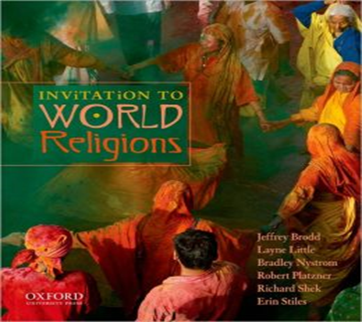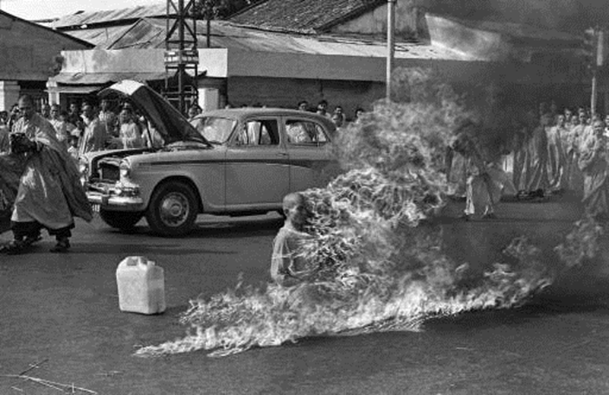
"All religions are one. They teach a divine life. I respect saints and prophets of all religions. I respect all religions, all cults, all faiths and all creeds. I serve all, love all, mix with all and see the Lord in all."- Swami Sivananda
“The world’s religious rivals do converge when it comes to ethics, but they diverge sharply on doctrine, ritual, mythology, experience and law. These differences may not matter to mystics or philosophers of religion, but they do matter to ordinary religious people.”- Stephen Prothero

Stuart Squires, Ph.D.
Stuart.Squires@brescia.edu
Office Hours: MWF: 8:50-9:50; 10:50-11:55
TTh 11:00-11:55
(Appointments highly recommended)
Office: Lechner #218
Fall 2013
Theology 219 9:30-10:50 in S226

Purpose and Learning Objectives:

This class surveys five different religions—Hinduism, Buddhism, Judaism, Christianity, and Islam. The first objective of this class is to look closely at each of these religions and determine how they think about the world through studying their great texts. Our second is to continually ask: “how are these religions similar, and how are they different?” Third, we will study how these religions address one of the most important questions that all religions address in one form or another: the question of human suffering. Important texts from Patanjali, the Buddha, The Hebrew Bible, Saint John, Blessed John Paul II, and the Koran are read and discussed.
FORMAT OF THE CLASS:

- The class will begin with a review of the previous lesson: the best way to learn something is by repetition.
- Classes will consist of lectures, close reading of primary texts, discussions, and (occasionally) videos.

TEXTBOOKS AND MATERIALS:

- Fisher, Mary Pat. Living Religions: A Brief Introduction. Third Edition. Upper Saddle
River: Pearson, 2012. (Hereafter: LR). ISBN: 0-205-22970-0.
- Other primary source material will also be used. This material will be found on the LibGuide.

REQUIREMENTS:

- Attendance: Students may miss up to four classes for the semester. After that, the student will lose 100 points. A student is counted present only when the student signs the attendance sheet at the beginning of the class.
- Quizzes: At the end of each unit, students will take a quiz covering the reading material (not lecture material or media) for that unit. Students will have 20 minutes to answer 10 questions. Students may use their notes and texts.
- Midterm and final exams. Make sure your travel plans at the end of the semester do not conflict with the final exam. You may not take the exam at any time other than when Brescia has specified.
- Paper: Students will write a 5-7 page paper. There are several options from which to choose. Students will submit their papers two ways. First, they will submit a hardcopy on the day that the paper is due. Second, students will upload a copy to Turnitin. Failure to do both will result in a 0.
  - Option 1: Choose two of the five religions we have compared this semester. Make an argument that either agrees with Smith (who argues that both religions are fundamentally the same), or with Prothero (who argues that both are fundamentally different). Or, are they both? Which aspects are similar and which are different?
  - Option 2: You may do a standard research project that should consist of you making an argument. In other words, don’t just give a summary; have a thesis. Your topic must be approved by the teacher by Week 12. You must use 6-8 sources (only one encyclopedia; Wikipedia is never a valid source; only one dictionary; you may only have a maximum of two websites; you must have a minimum of 4 books or scholarly journal articles).
  - Option 3: Students may do a project—paper or other— that is not listed here and employs the particular creativity of the student. If this option is chosen, students must get the project approved by the instructor by week 13.
Style: The student will use: Times New Roman; 12 point font; double spacing; 1 inch margins.

Grade Distribution:
Attendance: 100 pts
Quizzes: 50 pts
Midterm: 100 pts
Final: 100 pts
Paper: 100 pts

Grading Scale:
Grade |  | Meaning | Equivalent
 | A | Excellent | 100-92
 | A- |  | 91-90
 | B+ |  | 89-87
 | B | Good | 86-82
 | B- |  | 81-80
 | C+ |  | 79-77
 | C | Satisfactory | 76-72
 | C- |  | 71-70
 | D | Lowest Passing | 69-60
 | F | Failing | 59-0

POLICIES AND EXPECTATIONS:

- If the student chooses to come to class, he or she must not be tardy, as arriving late is distracting to the instructor, disruptive to colleagues, and it is disrespectful. If the student is late, the student should sit in the row closest to the door (which should remain empty) so as to cause as little disturbance as possible.

- Students may submit assignments before the deadline. However, if a student turns in work after the deadline, 20% will be deducted from the grade. The sole exception to this policy is if the teacher hears from the Dean of Students due to a case of extreme emergency.

- Students must do all of the reading for the week and bring all of the texts that are assigned for the week to class.

- There is to be no texting, emailing, or instant messaging during class.

- Students may not sleep in the class.

- Students must regularly check their Brescia email account as I will be emailing important information to it.

- STUDENTS WITH DISABILITIES POLICY: Any student who may need special accommodations needs to speak to me privately at the beginning of the quarter. The instructor, student, and university will make any necessary accommodations to assist the student in completing the quarter.

- ACADEMIC INTEGRITY STATEMENT POLICY: There is to be absolutely no plagiarism in this class. If you are unsure about what constitutes plagiarism, there are two things you should do BEFORE you submit an assignment: (1) read the plagiarism statement that is available on the Brescia University website; (2) ask the teacher. If a student is caught, he or she will be reported to the University and will fail the course.

- This class fulfills the major requirement for the Theology major and is a GER approved course.

The Schedule for the Quarter

Method: Are Religions Fundamentally the Same or Different?
Tues. Aug. 27: Selections from Huston Smith’s The World Religions (handout)
Thurs. Aug. 29: Selection from Stephen Prothero’s God is Not One.

Hinduism:
Tues.: Sep. 3: Yoga Sutra pp. 29-43
Thurs. Sep. 5: Yoga Sutra pp. 44-59
Tues. Sep. 10: Yoga Sutra pp. 60-83
Thurs. Sep. 12: Bhagavad Gita pp. 21-61
Tues. Sep. 17: Bhagavad Gita pp. 97-154
Thurs. Sep. 19: LR pp. 41-70. Quiz.

Buddhism:
Tues. Sep. 24: The Life of the Buddha pp. 57-72
Thurs. Sep. 26: The Four Noble Truths, pp. 15-17; False Doctrines about the Soul, pp. 20-1; Simile of the Chariot, pp. 21-23.
Tues. Oct. 1: Change and Identity, pp. 23-4; The Process of Rebirth, pp. 24-25; The Buddha in Nirvana, p. 30;
Thurs. Oct. 3: The Class and Caste in Buddhism, p. 48-51; Emptiness, pp. 95-97; Faith in Emptiness, p. 97; Karma and Rebirth, pp. 98-99.
Tues. Oct. 8: LR pp. 92-108. Quiz

Midterm and Fall Break:
Thurs. Oct. 10: Review for Midterm
Tues. Oct. 15: Midterm
Thurs. Oct. 17: NO CLASS

Judaism:
Tues. Oct. 22: Genesis, chapters 12 through 23; Exodus, chapters 19 through 20, 32 through 33; Deuteronomy, chapters 9 through 11.
Thurs. Oct. 24: The Book of Amos
Tues. Oct. 29: Job, chapters 1 through 10, 21, 28, 38 through 42.
Thurs. Oct. 31: LR pp. 147-184, and Quiz

Christianity:
Tues. Nov. 5: The Gospel According to John
Thurs. Nov. 7: Letter to the Hebrews chapter 11; James chapter 2
Tues. Nov. 12: Blessed Pope John Paul II, Salvifici Doloris: On the Christian Meaning of
Human Suffering.
Thurs. Nov. 14 LR pp. 185-205, and Quiz

Islam:
Tues. Nov. 19: Selections from the Koran pp. 43-121.
Thurs. Nov. 21: Selections from the Koran pp. 123-155.
Tues. Nov. 26: Selection from Problems of Suffering in the Religions of the World: Islam.
Thurs. Nov. 28: NO CLASS
Tues. Dec. 3: LR pp. 239-274, Quiz.
Thurs. Dec. 5: Paper Due. Review for final

FINAL EXAM:___________________________

